Removing Outliers

Definition
# Source: AI Source: Provided by: [Data Path: Persons Table -> ID Column: 1, Name_En Column: Motasem Essam] -> From: [Chatgpt (GPT‑5 Mini)] on [12/10/2025]
Removing Outliers is the process of identifying and eliminating data points that are significantly different from the rest of the dataset.
- Outliers can skew analysis, distort averages, and create misleading results.
- They may occur due to errors in data entry, measurement mistakes, or naturally extreme values.

Key idea:
# Source: AI Source: Provided by: [Data Path: Persons Table -> ID Column: 1, Name_En Column: Motasem Essam] -> From: [Chatgpt (GPT‑5 Mini)] on [12/10/2025]
It’s like removing extremely tall or short objects from a set of measurements so the overall analysis is more representative.

Characteristics
# Source: AI Source: Provided by: [Data Path: Persons Table -> ID Column: 1, Name_En Column: Motasem Essam] -> From: [Chatgpt (GPT‑5 Mini)] on [12/10/2025]
- Focuses on values far from the normal range
- Can be applied to numerical and sometimes categorical data
- Often uses statistical methods: Z-score, IQR (Interquartile Range), or standard deviation
- Helps improve accuracy of mean, median, and predictive models
- Can be automated using data analysis tools or scripts

Examples

1. Sales Data Outlier
# Source: AI Source: Provided by: [Data Path: Persons Table -> ID Column: 1, Name_En Column: Motasem Essam] -> From: [Chatgpt (GPT‑5 Mini)] on [12/10/2025]
Before cleaning:
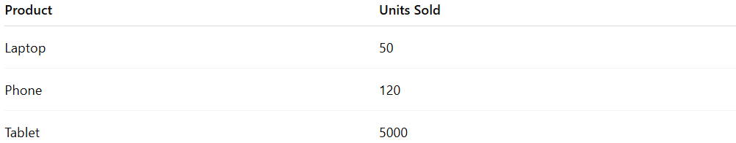
Product | Units Sold
Laptop | 50
Phone | 120
Tablet | 5000
- Tablet’s 5000 units are much higher than typical sales and may be a data entry error.
After removing outlier:
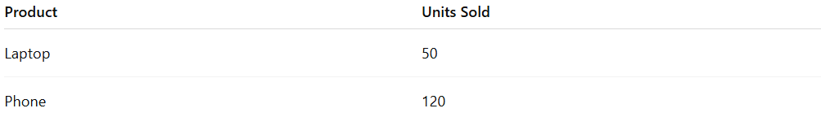
Product | Units Sold
Laptop | 50
Phone | 120

2. Test Scores Outlier
# Source: AI Source: Provided by: [Data Path: Persons Table -> ID Column: 1, Name_En Column: Motasem Essam] -> From: [Chatgpt (GPT‑5 Mini)] on [12/10/2025]
Before cleaning:
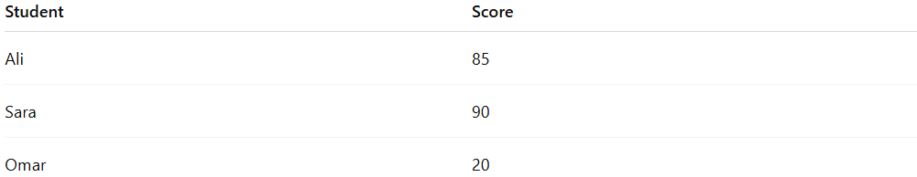
Student | Score
Ali | 85
Sara | 90
Omar | 20
- Omar’s score of 20 is far lower than the rest and may indicate an error or an exceptional case.
After removing outlier:
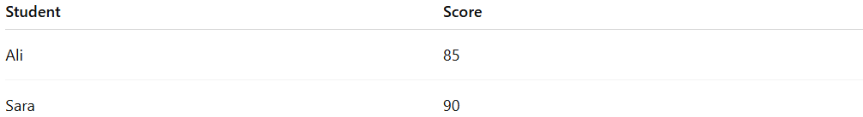
Student | Score
Ali | 85
Sara | 90

3. Salary Data Outlier
# Source: AI Source: Provided by: [Data Path: Persons Table -> ID Column: 1, Name_En Column: Motasem Essam] -> From: [Chatgpt (GPT‑5 Mini)] on [12/10/2025]
Before cleaning:
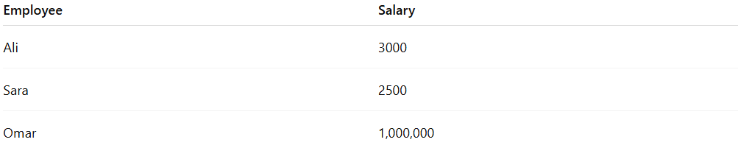
Employee | Salary
Ali | 3000
Sara | 2500
Omar | 1,000,000
- Omar’s salary is extremely high compared to others.
- It may distort average salary calculations.
After removing outlier:
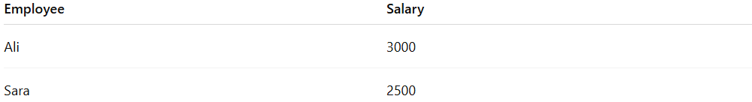
Employee | Salary
Ali | 3000
Sara | 2500

Example Section
# Source: AI Source: Provided by: [Data Path: Persons Table -> ID Column: 1, Name_En Column: Motasem Essam] -> From: [Chatgpt (GPT‑5 Mini)] on [12/10/2025]
A company collects employee ages for analysis:
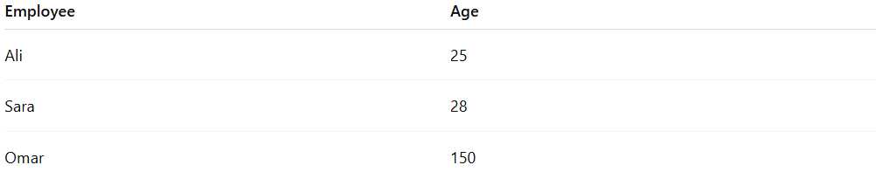
Employee | Age
Ali | 25
Sara | 28
Omar | 150
- Omar’s age is unrealistic and could be a data entry mistake.
- Cleaning removes the outlier:
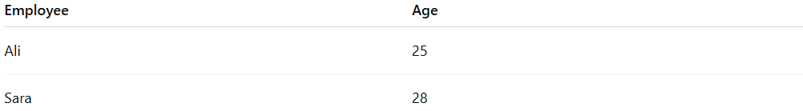
Employee | Age
Ali | 25
Sara | 28
- This ensures accurate statistics and meaningful analysis.

Advantages
# Source: AI Source: Provided by: [Data Path: Persons Table -> ID Column: 1, Name_En Column: Motasem Essam] -> From: [Chatgpt (GPT‑5 Mini)] on [12/10/2025]
- Improves accuracy of statistical calculations (mean, median, variance)
- Reduces bias in predictive models and analysis
- Helps identify data entry errors or anomalies
- Makes visualizations and reports more representative

Disadvantages
# Source: AI Source: Provided by: [Data Path: Persons Table -> ID Column: 1, Name_En Column: Motasem Essam] -> From: [Chatgpt (GPT‑5 Mini)] on [12/10/2025]
- May remove valid extreme values, losing important information
- Requires careful judgment to distinguish errors from real data
- Can impact sample size if too many outliers are removed
- Automated methods may misclassify data points as outliers

